Assignment 1:

Turning Colourful image into black & white:

Before image:

Steps:

* Open an image.
* Go to Image -> Adjustments -> Black & White, a pop up box opens.
* Adjust the colors (if needed) and click OK.
* Save your master piece.

After image:

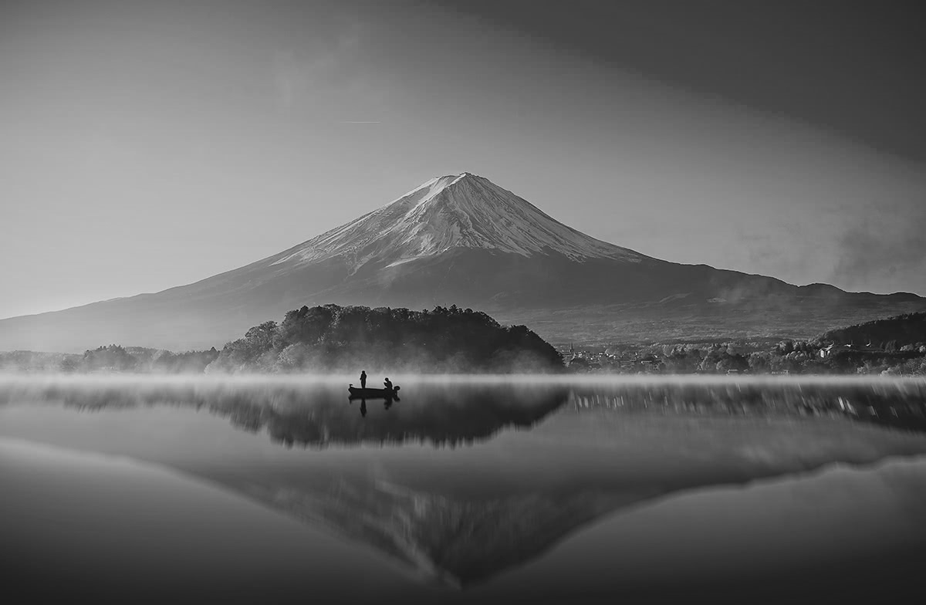

Assignment 2:

Change the background color of the image to black and white.

Before image:



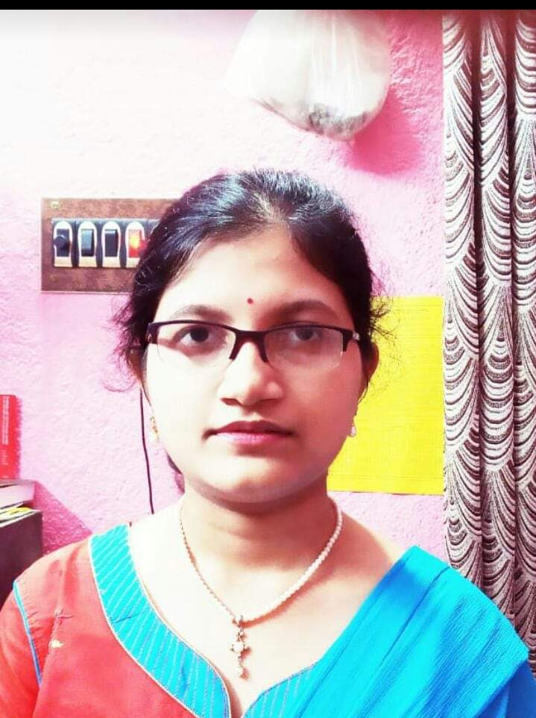

Steps:

* Open an image.
* Select Quick Selection Tool (left menu list) and use it to select the fore ground.
* Use “Brush +”, “Brush -“ and “Brush size selector” opetions of Quick Selection Tool (top menu list) to respectively select, deselect portion of image and change brush size.
* After the image is selected, Right Click on the image and select “Select Inverse”, to select the back ground.
* Go to Image -> Adjustments -> Black & White, a pop up box opens.
* Adjust the colors (if needed) and click OK.
* Right Click on the image and select “Deselect”.
* Save your master piece.

After image:



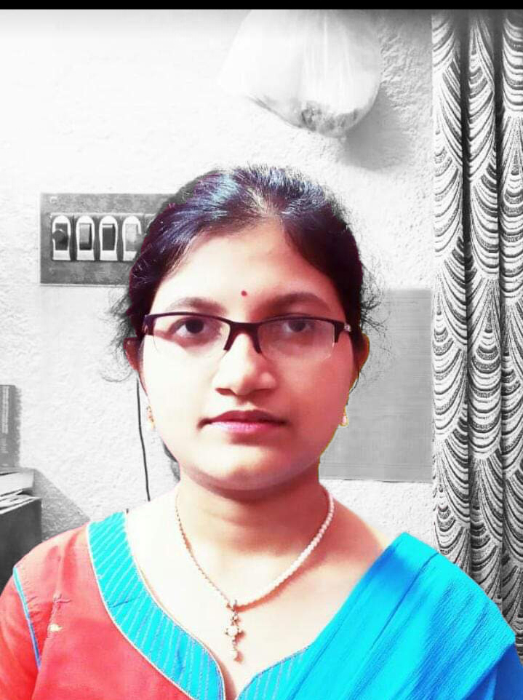

Assignment 3:

Create a passport size photo of the person.

Before image:

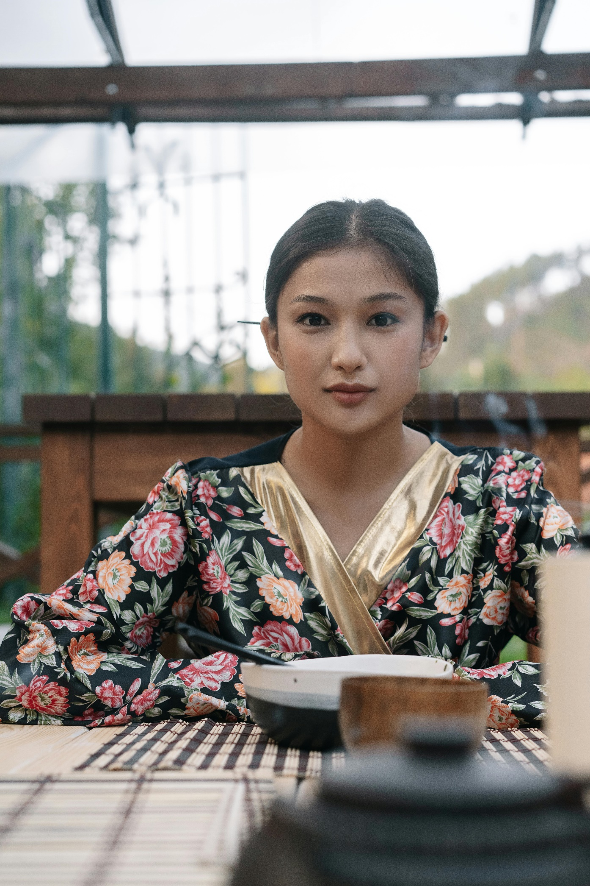

Steps:

Remove background

* Open the image.
* Crop the image if necessary.
* Select Quick Selection Tool (left menu list) and use it to select the fore ground.
* Use “Brush +”, “Brush -“ and “Brush size selector” opetions of Quick Selection Tool (top menu list) to respectively select, deselect portion of image and change brush size.
* After the image is selected, Right Click on the image and select “Select Inverse”, to select the back ground.
* Right Click on the image and select “fill”, use: color, white.
* Right Click on the image and select “Select Inverse”, to select the fore ground.
* Right Click on the image and select “refine edge” and adjust edges.

Make passport size (3.5cm x 4.5 cm)

* Select crop tool, set aspect ratio 3.5 x 4.5, and crop it.
* Go to Image -> Image size, set the following,
  + Width = 3.5 cm
  + Height = 4.5 cm
  + Resolution = 1000 pixels per inch
* Go to Image -> Canvas size, set the following,
  + Width = 3.55 cm
  + Height = 4.55 cm
  + Set a background color, Gray, to give the image a nice border.
* Create a new image (ctrl + n), set the following,
  + Width = 16 cm
  + Height = 20 cm
  + Resolution = 1000 pixels per inch
  + This image will hold 16 copies of passport size images.
* Select the image (ctrl + a), copy it (ctrl + c) and paste it (ctrl + v) on the new image. Which will create a new layer (say, layer 1) on the background of new image.
* Make background invisible, that makes moving the passport size image easier.
* Move the passport size image (layer 1) to the top left corner of the frame.
* Make multiple copies of this passport size image,
  + Right click on layer 1 in list of layers.
  + Select Duplicate layer.
  + Create one duplicate layer.
  + Drag and place the new (duplicate) layer image beside layer 1 image in the frame
  + Thus, 2 copies of that image is created.
* Now, marge these two layers,
  + Right click on layer 1 in list of layers
  + Select Marge Visible.
* Repeat last 2 steps until we have 16 copies of passport size images in the frame.
* Save your master piece.

After image:

Background removed

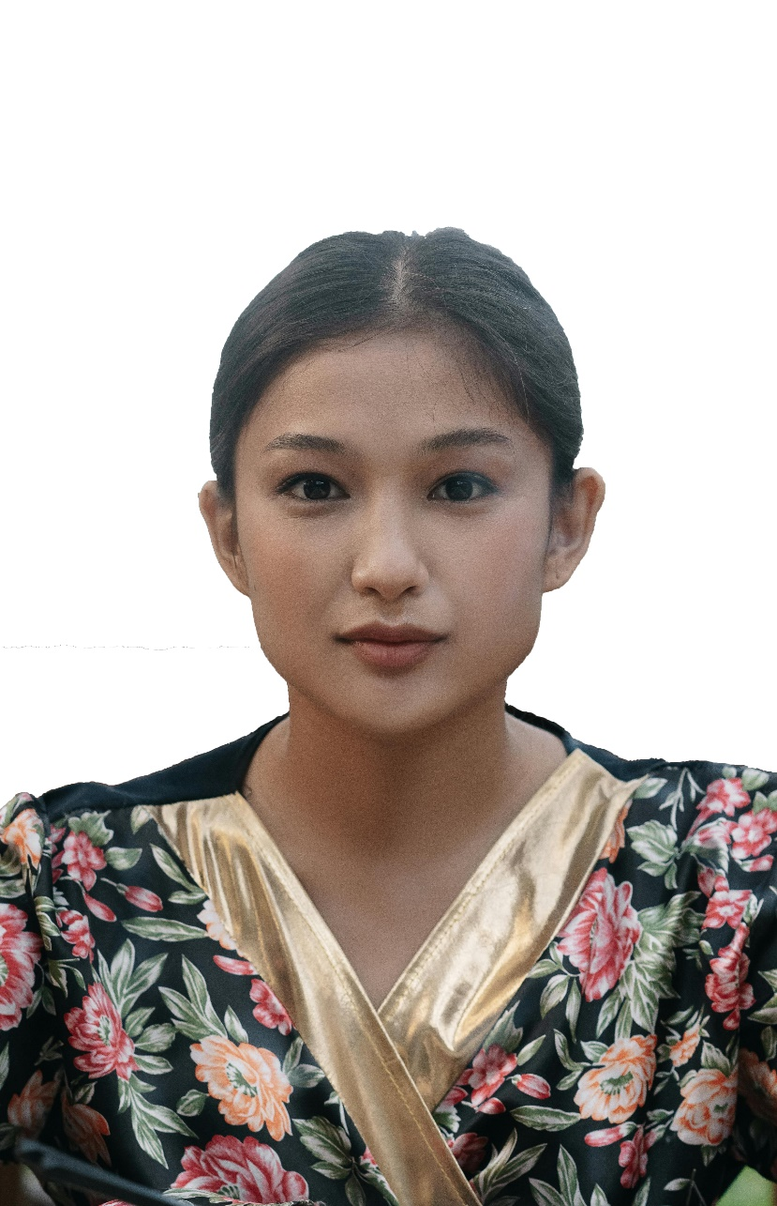

Single passport size photo

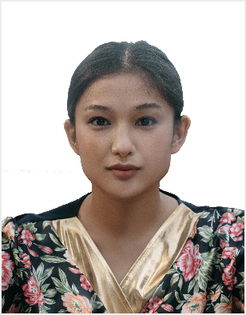

16 passport size photos

